

BY: KAFLE SUJAN

Water tank Simulink Model

The Simulink model water tank includes the nonlinear Water-Tank System plant and a PID controller in a single-loop feedback system.

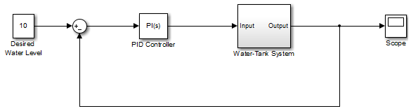

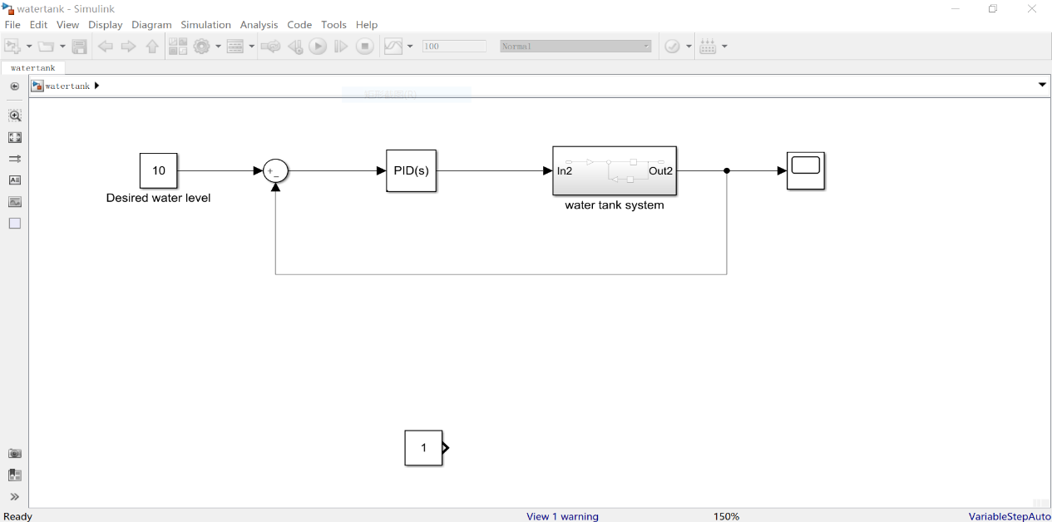

The Water-Tank System is shown in the following figure.

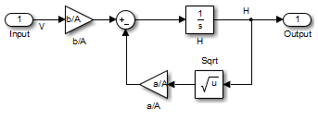

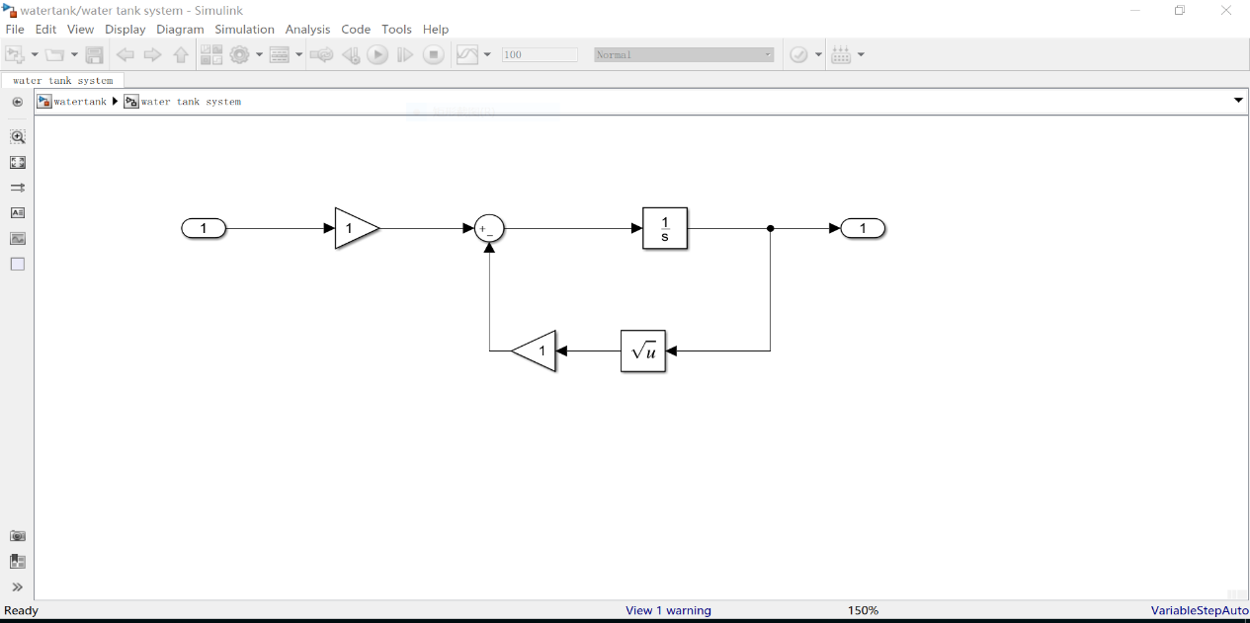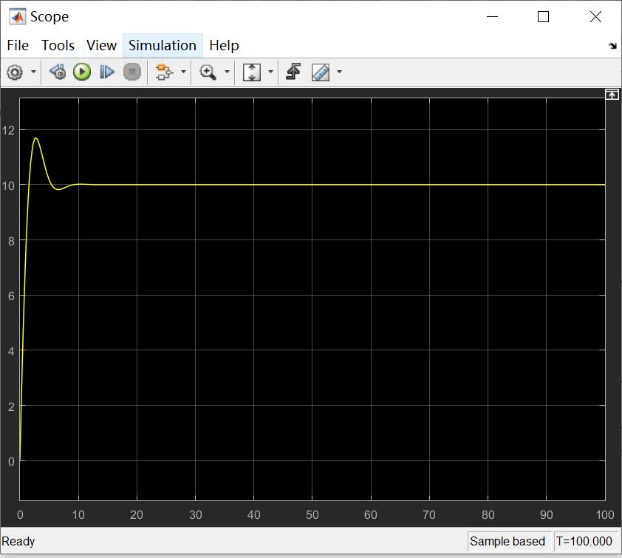Water enters the tank from the top at a rate proportional to the voltage, *V*, applied to the pump. The water leaves through an opening in the tank base at a rate that is proportional to the square root of the water height, *H*, in the tank. The presence of the square root in the water flow rate results in a nonlinear plant.

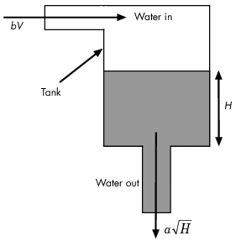

The following table describes the variables, parameters, differential equations, states, inputs, and outputs of the Water-Tank System.

|  |  |
| --- | --- |
| Variables | *H* is the height of water in the tank.  *Vol* is the volume of water in the tank.  *V* is the voltage applied to the pump. |
| Parameters | *A* is the cross-sectional area of the tank.  *b* is a constant related to the flow rate into the tank.  *a* is a constant related to the flow rate out of the tank. |
| Differential equation | *d/dt Vol*=*AdH/dt*= *bV*− *a sqrtH* |
| States | *H* |
| Inputs | *V* |
| Outputs | *H* |